NAME: Paula Andrea Gutiérrez Escobar

Part 2.1 Collecting data by playing

P2.1.1 Make a line chart with average contribution as the vertical axis variable, and period (from 1 to 10) on the horizontal axis. Describe how average contributions have changed over the course of the game.

P2.1.2 Compare your line chart with Figure 3 of Herrmann et al. (2008).1 Comment on any similarities or differences between the results (for example, the amount contributed at the start and end, or the change in average contributions over the course of the game).

P2.1.3 Compare your line chart with Figure 3 of Herrmann et al. (2008).1 Comment on any similarities or differences between the results (for example, the amount contributed at the start and end, or the change in average contributions over the course of the game).

P2.1.4 Can you think of any reasons why your results are similar to (or different from) those in Figure 3? You may find it helpful to read the ‘Experiments’ section of the Herrmann et al. (2008) study for a more detailed description of how the experiments were conducted.

Part 2.2 Describing data

P2.2.1. Using the data for Figures 2A and 3 of Herrmann et al. (2008):

1. Calculate the mean contribution in each period (row) separately for both experiments.
2. Plot a line chart of mean contribution on the vertical axis and time period (from 1 to 10) on the horizontal axis (with a separate line for each experiment). Make sure the lines in the legend are clearly labelled according to the experiment (with punishment or without punishment).
3. Describe any differences and similarities you see in the mean contribution over time in both experiments.

P2.2.2. Plot a column chart showing the mean contribution in the first and last period for both experiments.

P2.2.3. Using the data for Figures 2A and 3 of Herrmann et al. (2008)

1. Calculate the standard deviation for Periods 1 and 10 separately, for both experiments. Does the rule of thumb apply? (In other words, are most values within two standard deviations of the mean?)
2. As shown in Figure 2.3, the mean contribution for both experiments was 10.6 in Period 1. With reference to your standard deviation calculations, explain whether this means that the two sets of data are the same.

P2.2.4 Calculate the maximum and minimum value for Periods 1 and 10 separately, for both experiments.

P2.2.5. A concise way to describe the data is in a summary table. With just four numbers (mean, standard deviation, minimum value, maximum value), we can get a general idea of what the data looks like.

1. Create a table of summary statistics that displays mean, variance, standard deviation, minimum, maximum and range for Periods 1 and 10 and for both experiments.
2. Comment on any similarities and differences in the distributions, both across time and across experiments.

Part 2.3. How did changing the rules of the game affect behavior?

P2.3.1. You can conduct another experiment to understand why we might see differences in behaviour that are due to chance.

1. First, flip a coin six times, using one hand only, and record the results (for example, Heads, Heads, Tails, etc.). Then, using the same hand, flip a coin six times and record the results again.
2. Compare the outcomes from Question 1(a). Did you get the same number of heads in both cases? Even if you did, was the sequence of the outcomes (for example, Heads, Tails, Tails …) the same in both cases?

P2.3.2. Using the data for Figures 2A and 3:

1. Use the ttest function to calculate the p-value for the difference in means in Period 1 (with and without punishment).
2. What does this p-value tell us about the difference in means in Period 1?

P2.3.3. Using the data for Period 10:

1. Use the ttest function to calculate the p-value for the difference in means in Period 10 (with and without punishment).
2. What does this p-value tell us about the relationship between punishment, and behaviour in the public goods game?
3. With reference to Figure 2.7 and Figure 2.8, explain why we cannot use the size of the difference to directly conclude whether the difference could be due to chance.

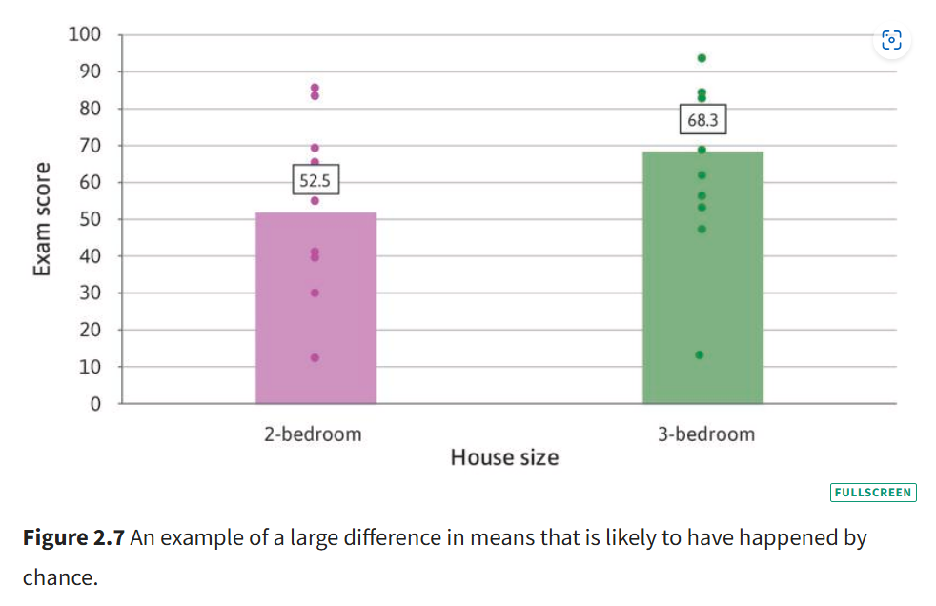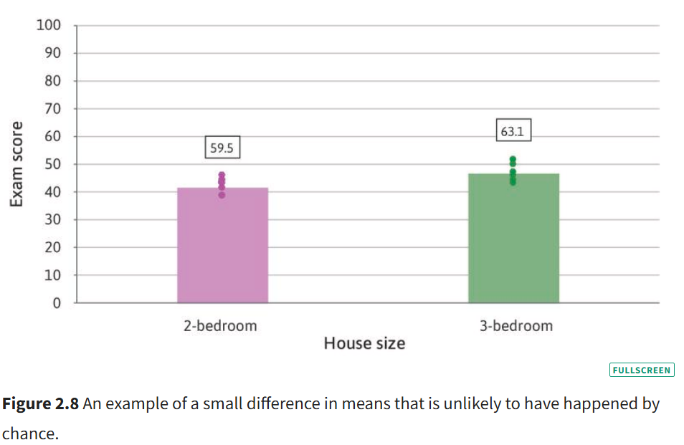

P2.3.4. Refer to the results from the public goods games.

1. Which characteristics of the experimental setting make it likely that the with punishment option was the cause of the change in behaviour?
2. Using Figure 2.6, explain why we need to compare the two groups in Period 1 in order to conclude that there is a causal link between the with punishment option and behaviour in the game.

P2.3.5. Discuss some limitations of experiments, and suggest some ways to address (or partially address) them. (You may find pages 158–171 of the paper ‘What do laboratory experiments measuring social preferences reveal about the real world?’ helpful, as well as the discussion on free riding and altruism in Section 2.6 of Economy, Society, and Public Policy.)